**SHIMONI DEMONSTRATION SCHOOL- KIRA**

**MID TERM TW0 EXAMINATIONS, 2023**

**MIDDLE CLASS, SOCIAL DEVELOPMENT**

**Name ____________________________________________________**

1. Match the same words.

Father baby

Mother sister

sister father

brother mother

baby brother

1. Name the people at home.

|  |  |  |  |  |
| --- | --- | --- | --- | --- |
|  |  |  |  |  |
|  |  |  |  |  |

**(Mother, baby, father, sister, brother)**

1. Draw the pictures

|  |  |  |
| --- | --- | --- |
| teacher | Cleaner | Cook |
|  |  |  |

1. Match to the belongings.

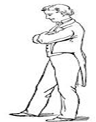 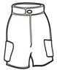

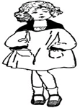 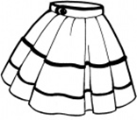

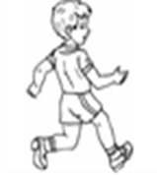 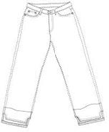

1. Colour the pictures.

 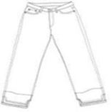

**END**